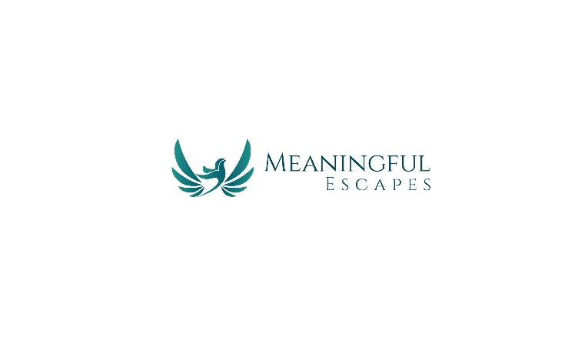
Black Friday Sales and Holiday Sales Terms & Conditions
- Sale Duration:
  - Black Friday discounts are valid from November 27, 2024, to December 3, 2024, and Holiday Sales from December 4, 2024 to December 31, 2024 times and sales may vary. No extensions will be granted.
- Eligible Products:
  - The sale applies only to select Meaningful Escapes travel gear, as specified on the promotional materials or website.
- Non-Combinable Offers:
  - Discounts, promotions, or offers during the Black Friday sale and Holiday sales cannot be combined with any other discounts, promotions, or coupons.
- Flash Sales:
  - Flash sales are available only during the time specified. Once the flash sale period ends, the discounted price will no longer apply.
- Shipping:
  - For luggage give-a-ways, shipping will occur 45 to 30 days prior to your departure date and full payment is confirmed, as provided during the purchase process. Please ensure accurate travel dates are submitted at the time of order.
  - Other items will ship according to standard delivery timelines. Shipping delays may occur due to increased demand, and Meaningful Escapes is not responsible for carrier-related delays.
- Non-Refundable Purchases:
  - All Black Friday sale purchases are final sale and non-refundable. Exchanges may be granted only for defective items, subject to availability.
- Order Changes or Cancellations:
  - Once an order is placed, changes or cancellations cannot be accommodated.
- Payment:
  - All payments must be completed at the time of purchase.
- Errors and Omissions:
  - Meaningful Escapes reserves the right to correct any errors, inaccuracies, or omissions related to the Black Friday promotion, including pricing and availability, even after an order has been placed.
- Policy Updates:
- Meaningful Escapes reserves the right to update or modify these terms at any time during the promotion.
- Customer Support:
  - For questions or concerns regarding your purchase, please contact us at info@meaningfulescapes.com or 803-603-5216
By participating in the Black Friday sale and Holiday sales, customers acknowledge and agree to these terms and conditions.

Thank you,
Meaningful Escapes Boutique Travel Agency
November 27, 2024 7:00 a.m.

